**PowerShell**

**Commands**

**INDEX**

1. PowerShell script installed applications list for Remote Computers
2. PowerShell Script to uninstall applications on Remote Computer
3. How to get Active Directory users list and attributes
4. Add client PC’s into DHCP reservation
5. Get remote PC serial number
6. Bulk AD users creation
7. **PowerShell script to get a list of installed applications in Remote Systems:**

**Get-WmiObject -Class Win32_product -ComputerName DC.test.com | select-object __SERVER, Name, Version -ErrorAction SilentlyContinue**

**Below is the screenshot for example**

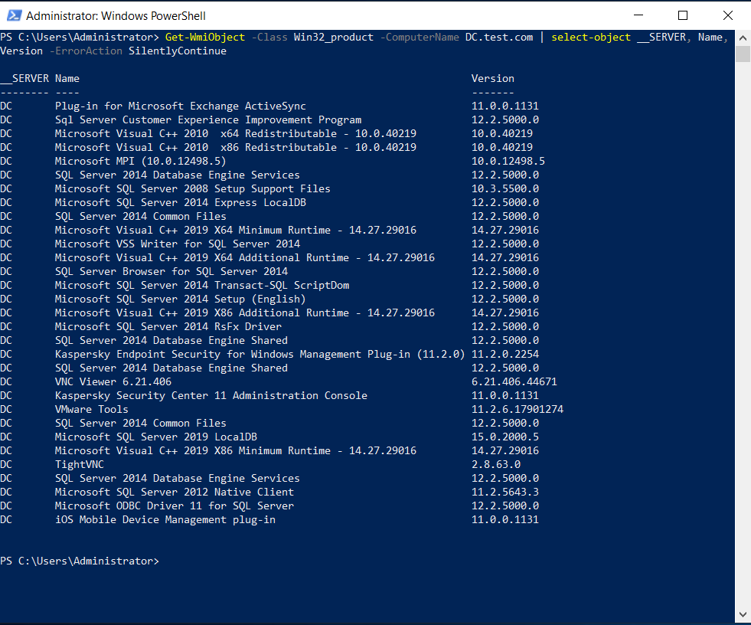

1. **PowerShell Script to uninstall applications on Remote Computer**

**$a = Get-WmiObject -Class Win32_product -ComputerName DC.test.com | where { $_.name -eq "Application name" }**

**$a.Uninstall()**

**Below is the screenshot for example**

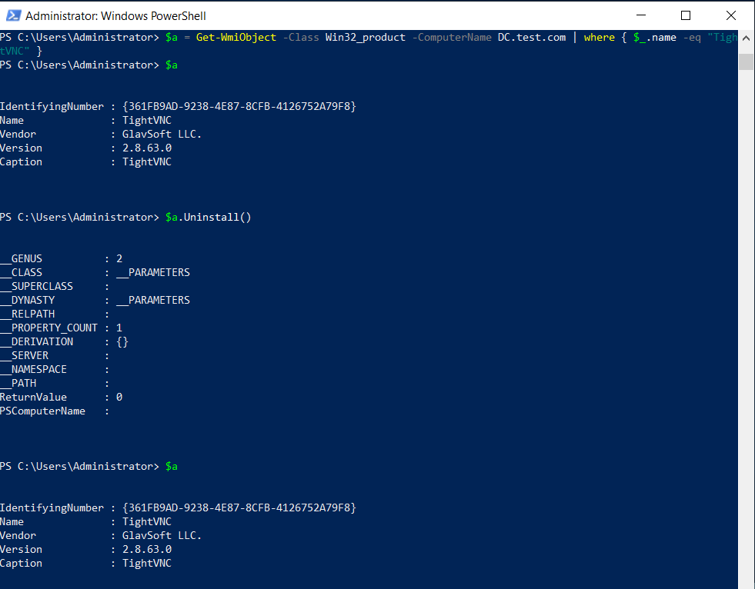

1. **Get the list of users and SID's:**

Import-Module ActiveDirectory

Get-ADUser -Filter 'Name -like "*"' -Properties * | Select-Object Name, SID

1. **Add client PC’s into DHCP reservation:**

Add-DhcpServerv4Reservation -ScopeId 192.168.1.0 -IPAddress 192.168.1.10 -ClientId 00-AA-SS-DD-CD-12 -Description “Pc name”

1. **Get remote PC serial number:**

Get-WmiObject win32_bios -ComputerName PC001

**6.Moving user from one OU to another**

Get-ADUser mm1234

Move-ADObject -Identity "CN=test1,CN=Users,DC=test,DC=com" -TargetPath "OU=test123,DC=test,DC=com"

**7.Adding desc to AD User**

Set-ADUser -Identity mm1234 -add @{ description= "Valassis" }

**8. Disable User accounts and move to Disabled Users OU in AD**

Get-ADUser -Identity "aa123" | Disable-ADAccount

Get-ADUser -Identity "aa123" | Move-ADObject -TargetPath "OU=Disabled users,DC=test,DC=com"

**OR**

$Pclist1 = Get-Content C:\users\MM1699\Desktop\names.txt

$Pclist1 | Get-ADUser | Disable-ADAccount

$Pclist1 | Get-ADUser | Move-ADObject -TargetPath "OU=Disabled users,DC=mediamint,DC=com"

**9. Mapping user account to pc’s**

Set-ADUser mm2778 -LogonWorkstations "CX-300"

**10. Create AD Users in Specified OU Using Powershell**

Get-Command New-ADUser -Syntax

$import_users = Import-Csv "C:\Users\MM1699\Desktop\adusers.csv"

$import_users | ForEach-Object {

New-ADUser `

-Path $_.Path `

-LogonWorkstations $_.LogonWorkstations `

-Name $_.Name `

-SamAccountName $_.SamAccountName `

-UserPrincipalName $_.UserPrincipalName `

-DisplayName $_.DisplayName `

-AccountPassword $(ConvertTo-SecureString $_.Password -AsPlainText -Force) `

-ChangePasswordAtLogon $True `

-Enabled $True `

-PassThru

}

**Below is the format to enter the user details in Excel sheet**

